|  |
| --- |
| **Palmly Neural Network Training:**  Software Development Plan (v 1.0) |

Project: Palmly Neural Network Training

Date: 9 October 2019

Prepared by: Nguyen, Katie; Ruiz, Sofia; Tolliver, Moriah

|  |
| --- |
| **4.1 Plan Introduction** |

This Software Development Plan contains information regarding the training of the neural networks that will ultimately be used in the Palmly mobile application. The team envisions Palmy to be an app that provides users with the opportunity to upload an image of their palm, which is then analyzed by aforementioned neural networks. Through the application, the user will then be presented with their specific palm reading, complemented by a lifestyle component that is individualized based on the user’s palm. While the mobile application will be the final product, the team will primarily focus on the data collection and training of the AI agent throughout the course of the first term. As currently forecasted, the majority of the data collection and labeling will take place in October 2019, where the training will be implemented through November 2019.

**4.1.1 Project Deliverables**

The Palmly Neural Network Training Project aims to deliver a dataset in addition to the three trained neural networks that are able to recognize the three major hand lines.

* Dataset – 1200 images of left palms (28-Oct-2019)
* Image Labeling Web App – a simple script that allows for the renaming of images with a given label
  + This tool will allow the team to examine a given image, select a label by choosing a preconfigured button, and store the image with its new name
* Labeled Dataset – 3 x 1200 images with a label classifying each image (1-Nov-2019)
  + The same dataset will be copied 3 times for each major palm line that the team will be observing (Head, Heart, Life Lines)
  + In each of those copies, a single label will be given to each image from the predetermined labels corresponding to each palm line
* 3 Trained Neural Networks – one for each hand line using the previously mentioned dataset to conduct such training (2-Dec-2019)
  + The networks will be trained using TensorFlow, a tool built upon Keras that enables machine learning to be on a device instead of sending data back and forth from a server.

|  |
| --- |
| **4.2 Project Resources** |

This section will detail the hardware and software resources necessary for the development and use of internal tools, as well as the development and use of the final neural networks.

**4.2.1 Hardware Resources**

Hardware will be used to collect participant data, to sort participant data through an online application in Google Drive, and to train the neural networks. The same hardware will be used for development and testing, as the end product is not user facing, but a tool that the team members will use.

**4.2.1.1 Team Member Personal Computers and Devices**

To collect data, every team member may use their personal laptop or mobile device to capture images of left palms to cultivate the data set. The only requirements for these devices are that they are able to send, receive, and capture images of types jpeg or png, and that they can connect to Google Drive. The team members will also use their respective devices to test the neural networks throughout development.

**2.1.2 Computer for Data Storage**

An Intel NUC7 with an i7 processor will be used to store the sorted data sets and to train the neural networks using TensorFlow.

Max Memory Size: 32 GB

Max Memory Bandwidth: 34.1 GB/s

**4.2.2 Software Resources**

This project will largely rely on the use of Google Drive for text editing, data collection, and data sorting. One internal tool will be developed using Google Scripts. TensorFlow will also be used to facilitate training the networks.

* Google Drive (automatically updates to latest version)
  + Docs
  + Forms
  + Slides
  + Scripts: Palmly Data Sorter (v4.0)
* Atom: Text Editor (v1.40.1)
* Chrome (v66.0.3359.181)
* TensorFlow: Machine Learning Platform (v2.0)
* Python: 3.7.4
* X-Code 11
  + iOS Simulator

|  |
| --- |
| **4.3 Project Organization/Human Resources** |

As previously stated, the team consists of three members: Katie Nguyen, Sofia Ruiz, and Moriah Tolliver. The work required to meet the stated deliverables will be the cumulation of individual and collaborative efforts. In regards to data collection, Katie will be the member responsible for overseeing this task and keeping the team on track in regards to meeting image collection goals. She will do this through actively asking for involvement and participation on campus, as well as externally through family and friends. The image labeling tool will be developed largely by Moriah. She will approach this problem by researching best known methods, languages, APIs, and platforms. Once a path has been determined, she will write the code to implement said tool.

In regards to labeling, training, and testing, the whole team will divide the work evenly. Throughout the process of labeling, each team member will be responsible for labeling all 1,200 images for one line only. In this sense, Moriah could label all Heart Lines, Katie could label all Head Lines, and Sofia would then label all Life Lines. For training purposes, the team will meet at designated times to train the neural networks on one system that contains all three copies of the dataset. Several meeting times are setup for this purpose throughout the month of November where at least 2 group members are able to be present. Testing will occur in a similar regard, with 2 or more group members physically present to test different versions of the trained models on the prelabeled test images.

|  |
| --- |
| **4.4 Schedule** |

This section provides schedule information for the Palmly Neural Network Training Project.

**4.4.1 GANTT Chart**

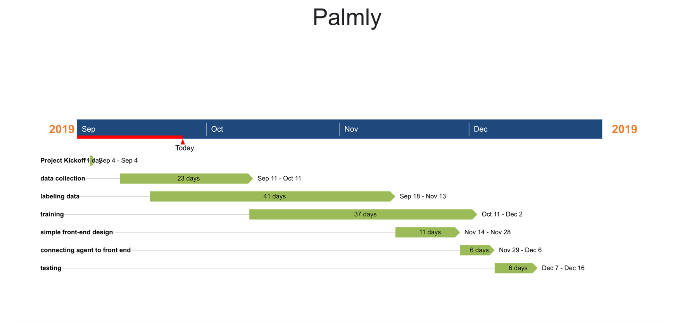

**4.4.2 Task/Resource Table**

|  |  |  |  |
| --- | --- | --- | --- |
| **Task** | **Team Member** | **Hardware** | **Software** |
| Data Collection | Katie | Phone Camera | Google Drive |
| Labeling Tool | Moriah | Personal Laptop | Google Scripts |
| Labeling | All | NUC | Google Drive, Labeling Tool |
| Training | All | NUC | TensorFlow |
| Testing | All | NUC | TensorFlow |

**Table of Contents**

4.1 Plan Introduction

4.1.1 Project Deliverables

4.2 Project Resources

4.2.1 Hardware Resources

4.2.2 Software Resources

4.3 Project Organization

4.4 Project Schedule

4.4.1 PERT / GANTT Chart

4.4.2 Task / Resource Table